**RPZ-93a**

**Work-case 1**

**Git**  is software for tracking changes in any set of files, usually used for coordinating work among programmers collaboratively developing source code during software development.



**Github** provides a home for your Git-based projects on the internet. The remote host acts as a distribution channel or clearinghouse for your Git-managed project. It allows other people to see your stuff, sync up with you, and perhaps even make changes.  
  
We work in group: Rostyslav Brovchenko and Volodymyr Zvieriev.   
We created accounts on github:

Rostyslav Brovchenko: <https://github.com/blamehaa>

Volodymyr Zvieriev:

<https://github.com/ZWER0B0Y>

Our repository:

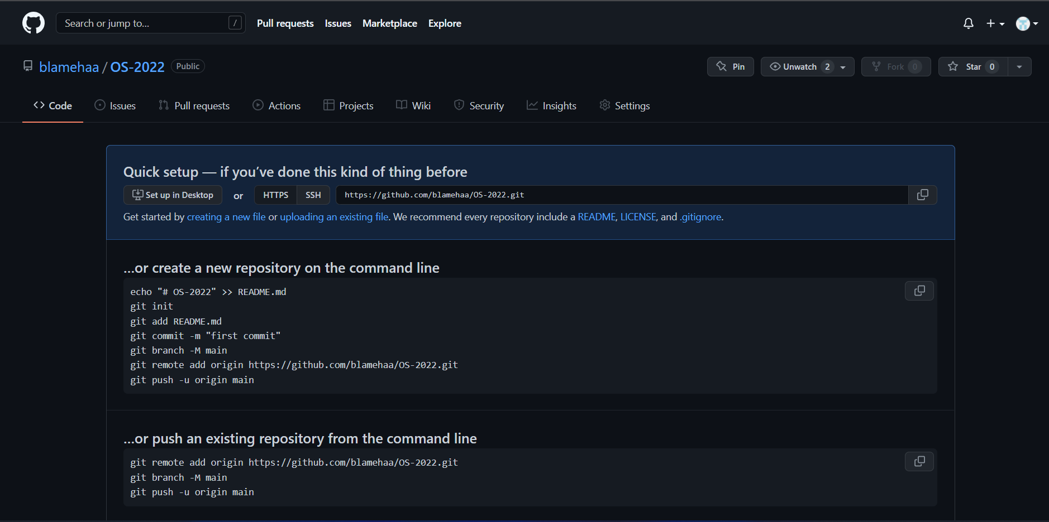

Link: <https://github.com/blamehaa/OS-2022>